Protocol for Treating Stress Urinary Incontinence (SUI) Using Low-Intensity
Shockwaves
Device: MoreNovaPro - Li50F Linear Transducer
Document Version: 2.0
Date: 16/12/2025
1. Purpose and Scope
This protocol provides a standardized treatment plan for using low-intensity shockwaves to
manage stress urinary incontinence (SUI). It is intended for healthcare providers using the
MoreNova Device with Li50F Transducer to target the tissues surrounding the urethra and
sphincter muscles. This protocol applies to women aged 20-75 diagnosed with SUI.
2. Introduction
Low-Intensity Extracorporeal Shockwave Therapy (LiESWT) is a non-invasive technology
that uses acoustic waves to stimulate tissue regeneration, enhance blood circulation, and
strengthen muscle function. It is clinically proven for treating stress urinary incontinence
(SUI) by targeting weakened pelvic floor muscles and the urethral sphincter. For further
information on clinical studies and efficacy, visit our Clinical Data Center.
Device Overview:
MoreNova is a portable Electromagnetic (EM) Low-Intensity Shockwave (LISW) device
designed to reduce inflammation, dissolve calcifications, and stimulate angiogenesis,
improving outcomes for various conditions in men and women.
3. Background
Condition Overview:
•
•
SUI is an involuntary leakage of urine due to increased abdominal pressure during
activities like coughing, sneezing, or exercising.
It often results from weakened pelvic floor muscles and urethral sphincter
dysfunction.
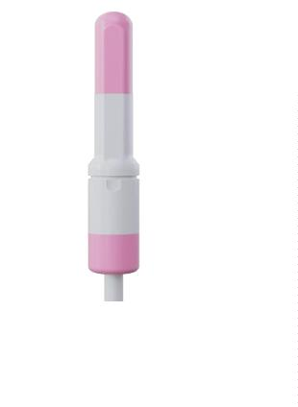

Mechanism of Action:
•
Low-intensity shockwave therapy stimulates neovascularization, enhances blood
flow, and promotes tissue regeneration, improving pelvic floor strength and
urethral function.
4. Patient Selection Criteria
Inclusion Criteria:
•
•
•
Women aged 20-75 years.
Diagnosed with SUI by a gynecologist for at least 3 months.
Persistent SUI symptoms despite conservative management.
Exclusion Criteria:
•
•
•
•
•
•
•
•
History of surgery in the vulvar or vestibular region.
Blood coagulation disorders.
Active pelvic inflammatory conditions.
Vaginal infections (e.g., yeast infection or bacterial vaginosis).
Pregnancy or lactation.
History of pelvic or external genitalia irradiation within the past year.
Chronic neurological disorders cause localized pain.
Presence of an electromagnetic-sensitive medical device.
5. Pre-Treatment Screening
To determine the patient's suitability for LiESWT, conduct the following:
•
•
•
Comprehensive medical history review.
Physical examination to assess pelvic floor condition.
Diagnostic tests: Urinalysis to rule out infections, and pelvic ultrasound for
anatomical assessment, if indicated.

6. Treatment Protocol
Preparation:
•
•
Conduct a thorough medical history and gynecological examination.
Counsel the patient about the procedure, benefits, risks, and expected outcomes.
Procedure:
•
•
•
•
Number of Sessions: 6-8 sessions based on severity.
Session Frequency: Twice per week.
Session Duration: 20 minutes. (angled rotation beneath the urethra)
Applications Per Session: 5.
The rotation pattern:
1
2
3
4
5
•
.
.
.
.
.
-30°
-15°
0° (beneath the urethra)
15°
30°
Shocks Per Application: 500.
•
Total Shocks Per Session: 2500.
Treatment Parameters:
•
•
Energy (HV) Settings: 2.0 kV.
Frequency (FRQ): 2.0 Hz.
Post-Treatment Care:
•
•
Advise patients to avoid strenuous physical activity for 24 hours.
Recommend hydration and report any adverse events.
7. Treatment Areas and Techniques
The treatment focuses on the following anatomical areas:
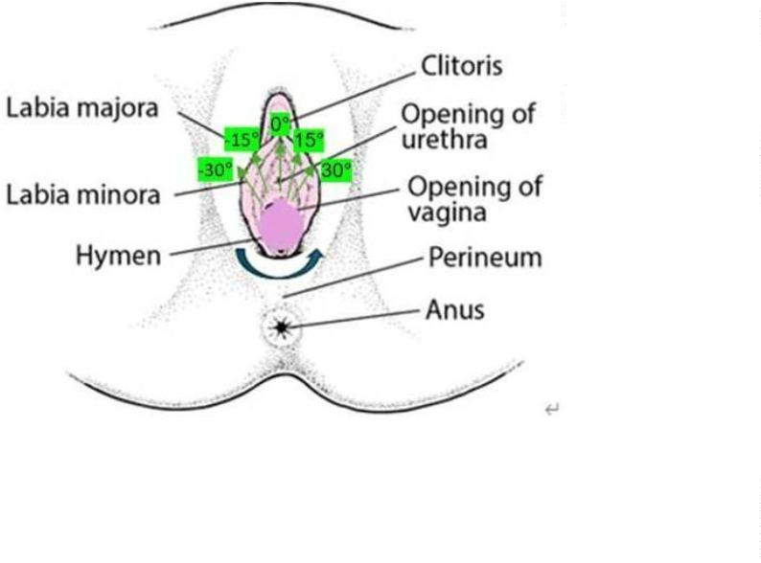

•
•
Pelvic floor muscles.
Urethral sphincter.
Ensure correct Transducer placement beneath the urethra and apply gentle pressure. Rotate
the Transducer in 15° increments to cover all necessary areas, following the predefined
sequence.
8. Patient Comfort and Safety
To ensure patient comfort and safety during the procedure:
•
•
•
Position the patient in a supine or lithotomy position for optimal access.
Use conductive gel for effective shockwave transmission and minimal discomfort.
Continuously monitor patient feedback during the session and adjust settings if
needed.
9. Treatment Outcomes and Follow-Up
Expected Results:
Patients typically experience symptom improvement within 3–6 weeks of starting
treatment. Regular assessments are recommended to evaluate progress.
Follow-Up Visits:
Schedule bi-weekly follow-ups to monitor patient outcomes and adjust the treatment plan
as needed.
Long-Term Maintenance:
For sustained improvement, consider maintenance sessions every 3–6 months based on
individual needs.
10. Visuals and Diagrams

Li50F
•
Anatomical areas being treated.
•
Rotation pattern for Transducer placement.
11. Quality Control
Device Calibration:
•
•
Verify device settings before each session.
The MoreNova Device recognizes preprogrammed parameters, ensuring correct
settings are automatically applied.
Clinician Training:
•
•
Ensure all operators are thoroughly trained in the use of the MoreNova Device and
Li50F Transducer.
Clinicians should be familiar with this protocol and review the "Instructions for Use"
provided by the manufacturer.
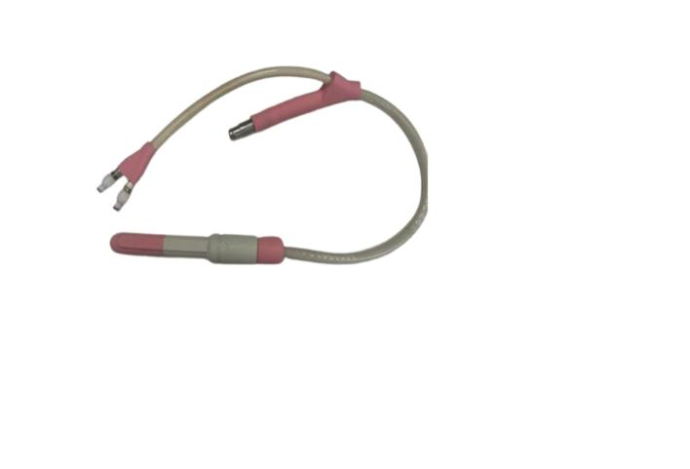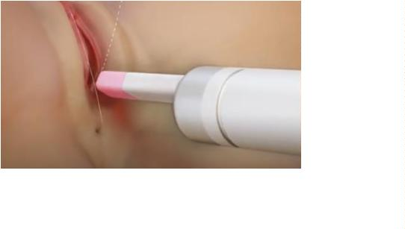

Checklist for Each Session:
•
•
•
Confirm that the patient meets the inclusion criteria and has no contraindications.
Ensure the device and Transducer are clean, sanitized, and function correctly.
Confirm that the Transducer placement aligns with the anatomical areas
specified in the protocol.
12. References
For clinical studies and additional resources, visit the Initia Clinical Data Center.

